Boron Nitride Coatings

High Temperature Coatings and Release Agents
for Aluminum, Magnesium, Zinc and Lead Foundries

Background

Our AMZL Release Agents use Hexagonal Boron Nitride powder as a key ingredient for utmost efficiency and can be formulated with Water, Oil or Ethanol. Due to the unique lubricating properties and inertness to molten metals and salts the Boron Nitride powder is ideally suited as a mold and die release agent for high temperature paints and coatings. We optimized our AMZL line of Release Agents to perform most efficiently in the tough conditions of Aluminum, Magnesium, Zinc and Lead foundry applications.

General Description of Products and Options

 | Boron Nitride Powder SEM Pictures |  |  |  | Active Ingredient: Boron Nitride Powder
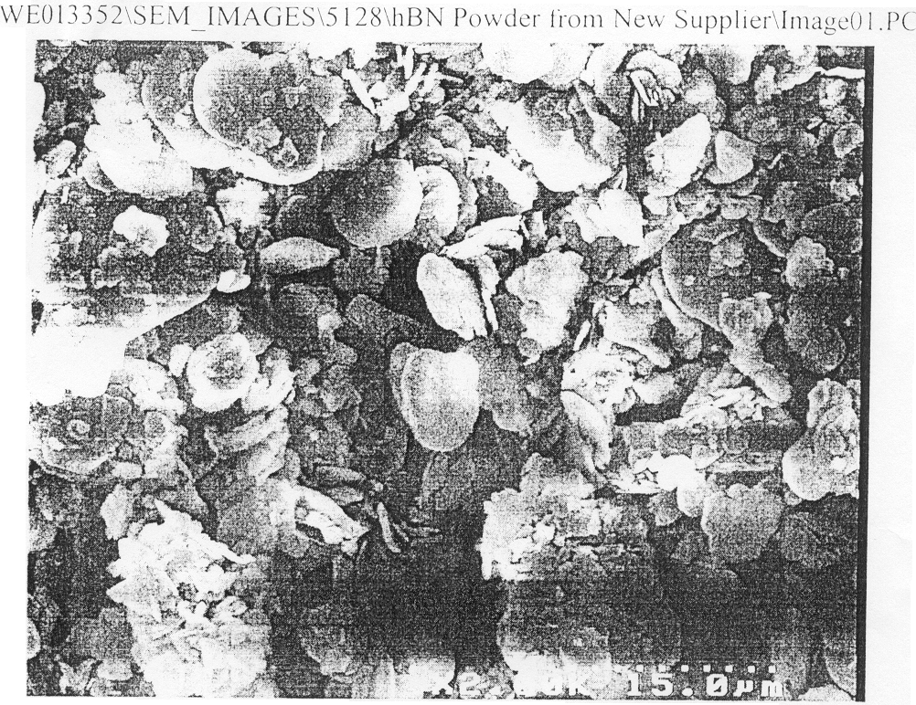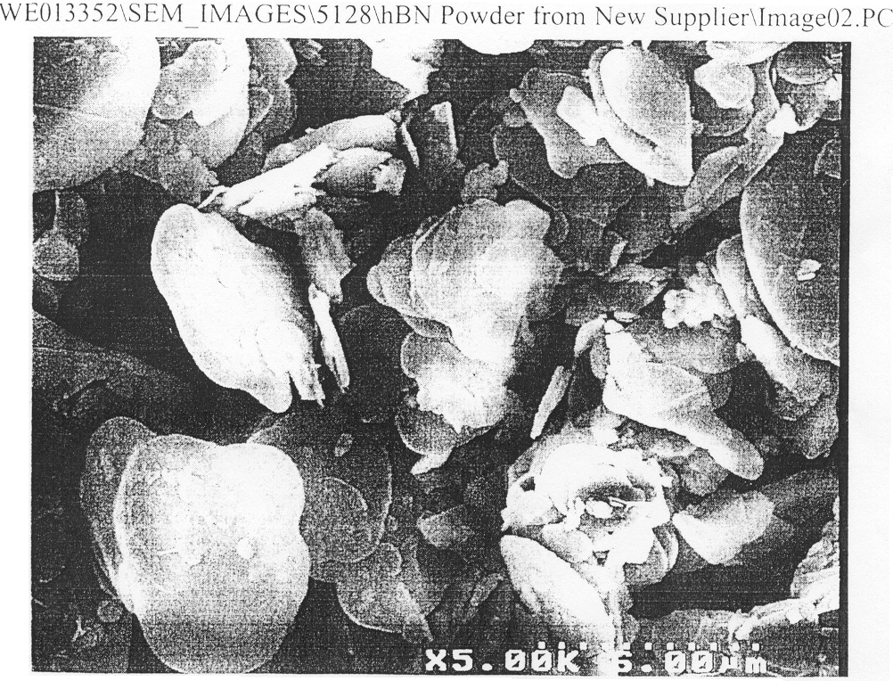 |  |  |  |  | Total B+N: | 99% min.
 |  |  |  |  | Oxygen: | 0.45% max.
 |  |  |  |  | Soluble Boron: | 0.25% max.
 |  |  |  |  | Free Carbon: | 0.02% max.
 |  |  |  |  | Magnetic Metals: | 0.07% max.
 | Boron Nitride Powder Content: |  |  | Varies from 5% to 40% depending on specific application.
 | Color: |  |  | Varies from white to blue to light brown.
 | Density: |  |  | Varies from 0.75 g/cm³ to 1.2 g/cm^{3.}
 | Viscosity: |  |  | From very light (suitable for spray guns) to heavy paste, available for entire range of Boron Nitride content.
 | Liquid Base: |  |  | Water, Oil or Ethanol.
 | Application Temperature: |  |  | 1350 C max.
 | Special Product Enhancements: |  |  | Are available on request including formulation with Alumina as a binding agent.
 | PH Level Range: |  |  | 2-12

Standard Product Formulations

Product | Application | BN content | Product No. | Application | BN content
MR | Mold Casting Release Coating | up to 10% | AWH | General Purpose High Temperature Coating-thicker composition | up to 25%
AWL | Anti-Wetting Coating for Metal, Ceramics & Graphite – thin composition | up to 25% | AWHD | Heavy Duty thick composition for coating parts that are moving in molten metal | up to 40%

Packaging Options

Standard packaging: 1 qt jar, ½ gal and 1 gal. bottle, 5 gal. plastic pail or 55 gal. plastic drum.

Bulletin HT-HBN Coating 6.11.2002 Rev. 2

