Hexagonal Boron Nitride Powder
HBN

Background

SEM Pictures of PG Grade HBN powder | Hexagonal Boron Nitride powder has a structure and properties similar to graphite. It has become one of the most popular dry lubricants due to its lubricating properties and inertness to molten metals and salts. It is used in many different applications, especially as a mold release agent. Hexagonal Structure Boron Nitride improves the strength and holding ability of the present powder composites.
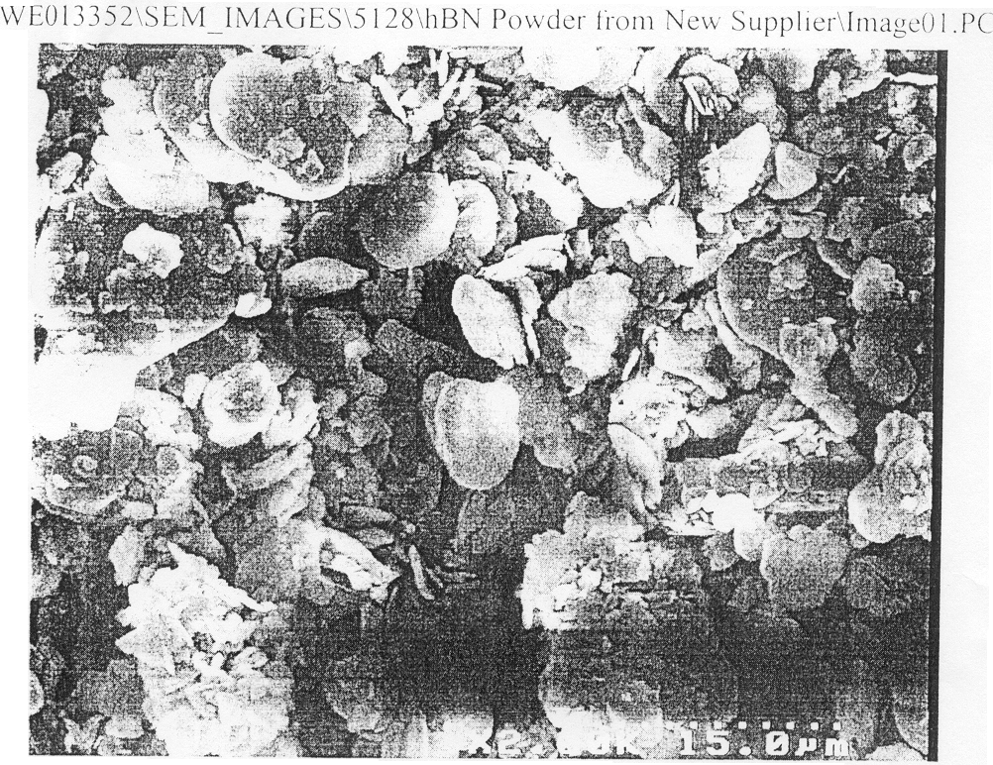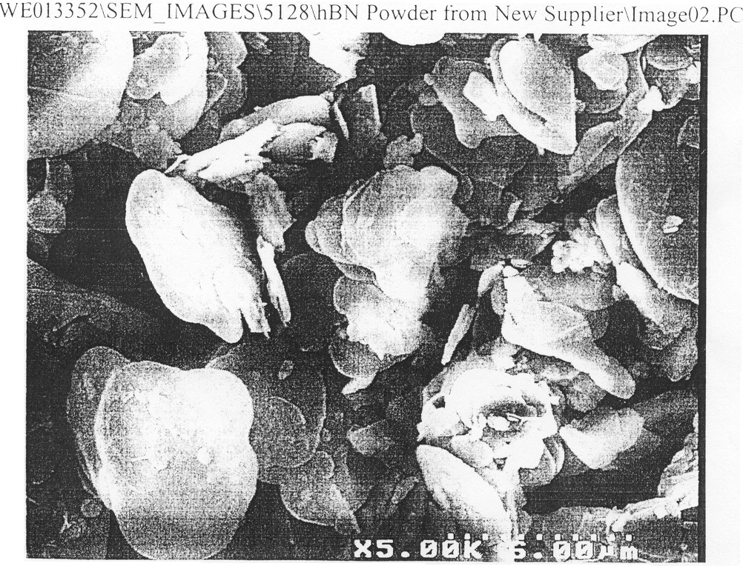

Product Availability
Hexagonal Boron Nitride powder is available in 3 grades: PG (Premium), SG(Standard) and CG (Custom). Custom grades are fine-tuned to the customer applications and are available on request. Grade CG-F is shown as an example in the chart below.

Technical data

- Grade |  | PG | SG | CG-F
- Typical Applications |  | Cosmetic Industry, high purity ceramics | - Paints and coatings  - Mold and die release agents.  - Ceramics  - Ceramic Coating  - Dry Lubricants | Misc. applications including ceramics
- Appearance (dry state): | Color | Pure White | White | White
- Chemical composition: |  | Typical | Specifications | Specifications
 | Chemical formula: | BN | BN | BN
 | Total B+N | 99.6% | 99% min. | 77% min.
 | Calcium | 0.014% | n/a | n/a
 | Free Carbon | 0.001% | 0.02% max. | 0.02% max.
 | Iron | 78 ppm | n/a | n/a
 | Oxygen | 0.03% | 0.45% max. | 12% max.
 | Soluble Boron | 0.2% | 0.25% max. | 2% max.
 | Chloride | 38 ppm | n/a | n/a
 | Aluminum | 78 ppm | n/a | n/a
 | Silicon | 0.001% | n/a | n/a
 | Lead | <0.1 mg/kg | n/a | n/a
 | Arsenic | <0.1 mg/kg | n/a | n/a
 | Mercury | <0.1 mg/kg | n/a | n/a
 | Magnetic Metals | 0.07% max. | 0.07% max. | 0.07% max.
 | Moisture: | 0.1% | 0.1% max. | 0.1% max.
- Physical data: | Particle Shape: | Similar to Graphite | Similar to Graphite | Similar to Graphite
 | Particle size D50 | 5.46 um | 5.46 um | 5.46 um
 | Surface Area | 7.4 m2/g | 7.4 m2/g | 7.4 m2/g
 | Bulk Density: | 0.4 g/cc3 | 0.4 g/cc3 | 0.4 g/cc3
 | Tap Density | 0.45 | 0.45 | 0.45
 | Structure: | Hexagonal | Hexagonal | Hexagonal

Availability of particle sizes

Boron Nitride powder typically comes in size of - 10um. Also available on request sizes -8 um and -5 um.

Bulletin BN\01. Rev.4 7.10.2002
9-1

